**Net Centric Project Documentation**

**Title**: HygeaHealth​

(An electronic heath record system)

**Date:** *15.10.2019*

**Team Members:**

|  |
| --- |
| Jagan Kaartik (AM.EN.U4CSE16029) |
| Athul Krishna TK (AM.EN.U4CSE16016) |
| ET Karthik Nambiar (AM.EN.U4CSE16023) |
| Arun Kumar S (AM.EN.U4CSE16013) |

**Table of Contents**

1. Abstract
   1. Introduction
   2. Purpose
2. Diagrams
   1. Users
   2. Use Case Diagram
   3. Sequence Diagram
   4. Class Diagram
3. Software Testing
   1. Test Plan
   2. UI/UX Screenshots

**Abstract**

HygeaHealth is a software which is intended to serve hospitals and other medical organizations which will help the hospital management and doctors to centralize the health record, manage and retrieve data in a convenient way.

**Introduction**

An Electronic Health Record (EHR) is an electronic version of a patients medical history, that is maintained by the provider over time, and may include all of the key administrative clinical data relevant to that persons care under a particular provider, including demographics, progress notes, problems, medications, vital signs, past medical history, immunizations, laboratory data and radiology reports.

A basic electronic health record application built on the Java EE Architecture which uses JSP, Servlets and PostgreSQL. The front end was developed with HTML/CSS/JS and a CSS Framework: Materialize CSS.

**Purpose**

This project is a prototype for the electronic health record system and it is restricted within the college premises. This has been implemented under the guidance of college professors. This project is useful for the hospital management team and as well as to the doctors.

The purpose of HygeaHealth is to ease health record management and to create a convenient and easy-to-use application for doctors. The system is based on a relational database with its health management and health tracking functions. This software can minimize a lot of physical files with the records. Above all, we hope to provide a comfortable user experience along with the best way to manage health records available.

**Users**

|  |  |
| --- | --- |
| **User classes** | **Description** |
| Administrator | A user who has completed the account activation. He owns expanded rights inside the application.. He performs the content pre moderation. |
| Receptionist | A user of the application who have the duties like registering patients to the application. |
| Doctor | A user of the application who diagnose patients and add the details of the disease and the medication required. |

**Use Case Diagram**

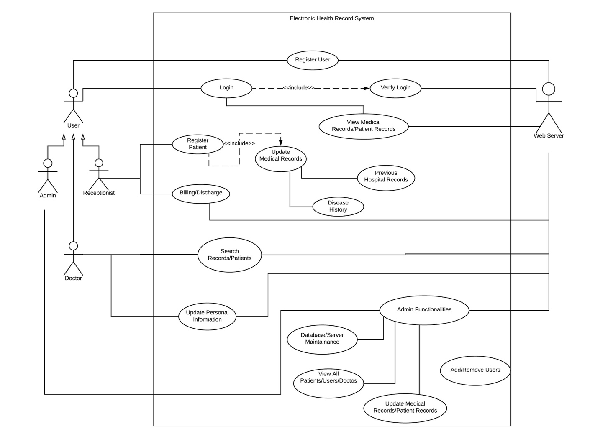

**Class Diagram**

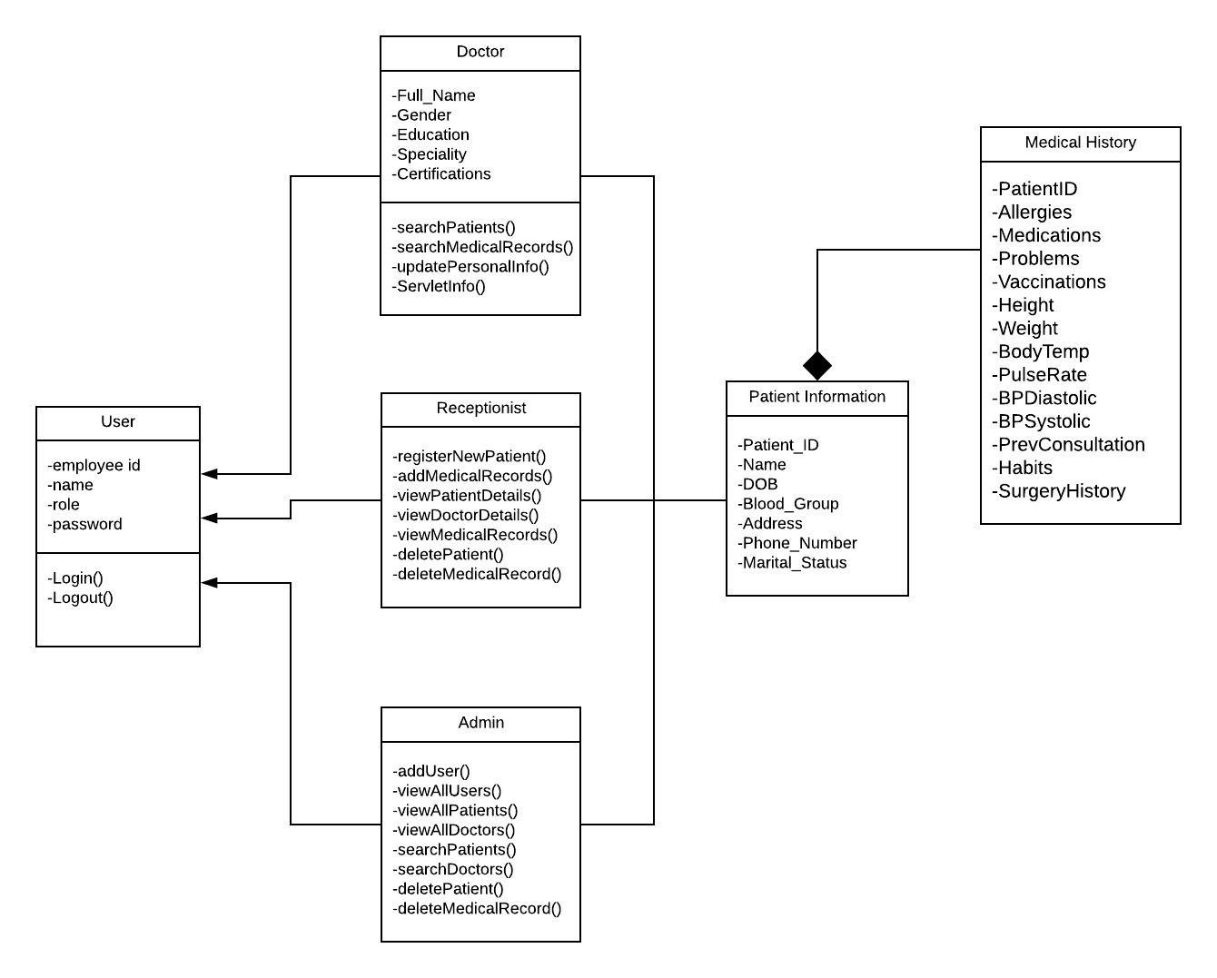

**ER Diagram**

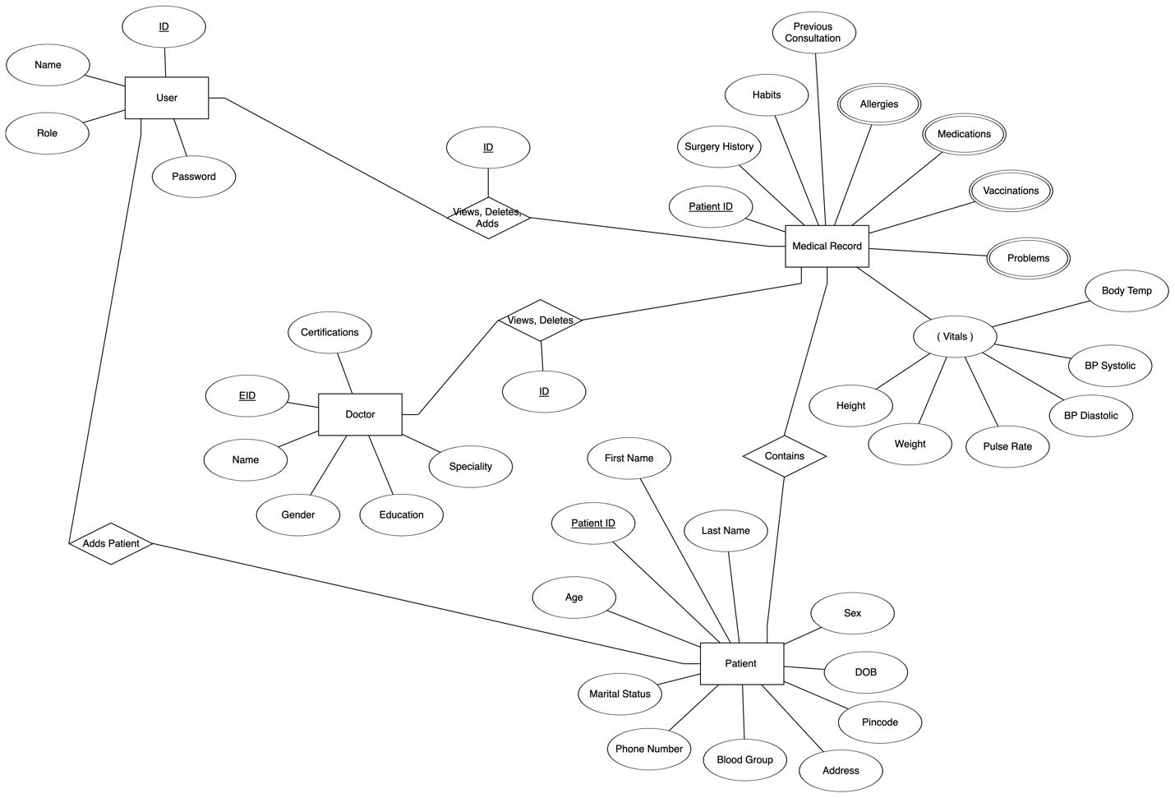

**Testing Screenshots**

Login Page

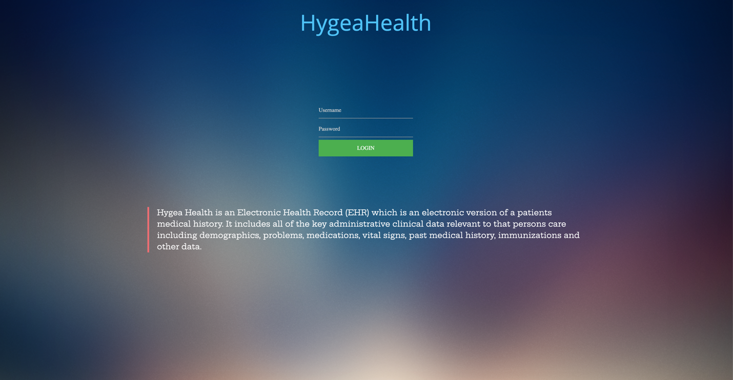

Registration Page via Admin

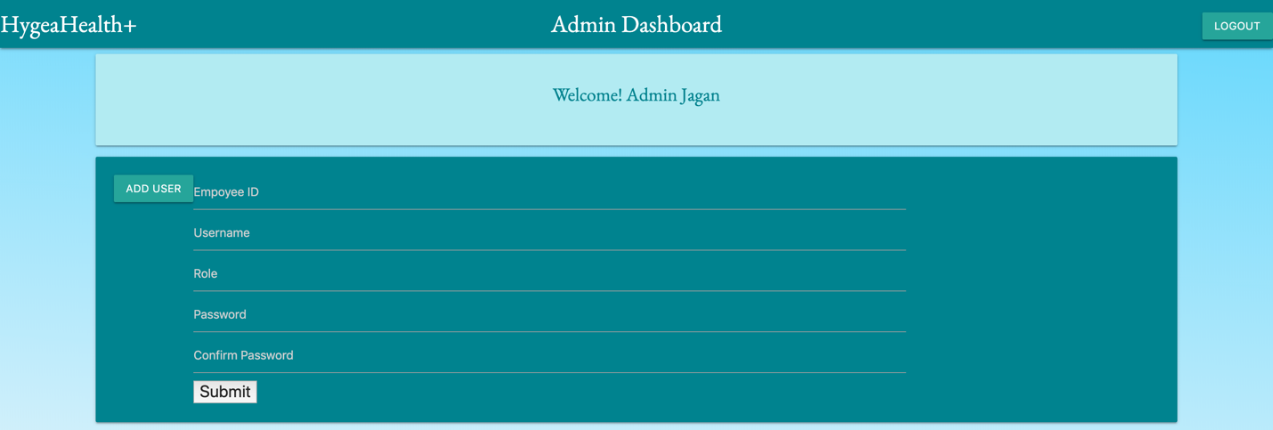

Dashboards

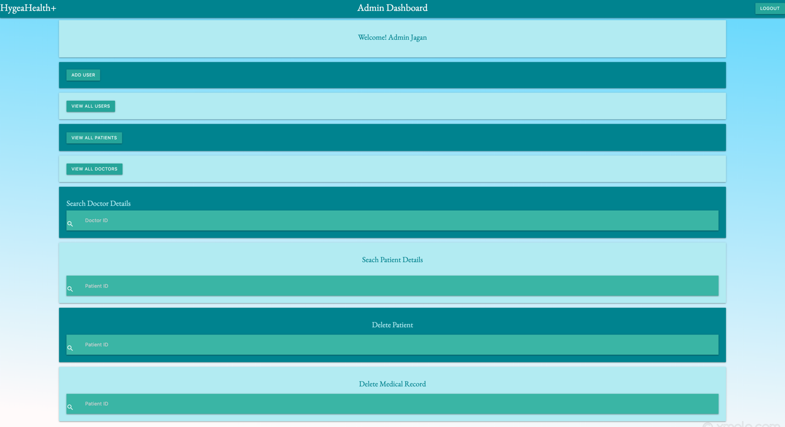

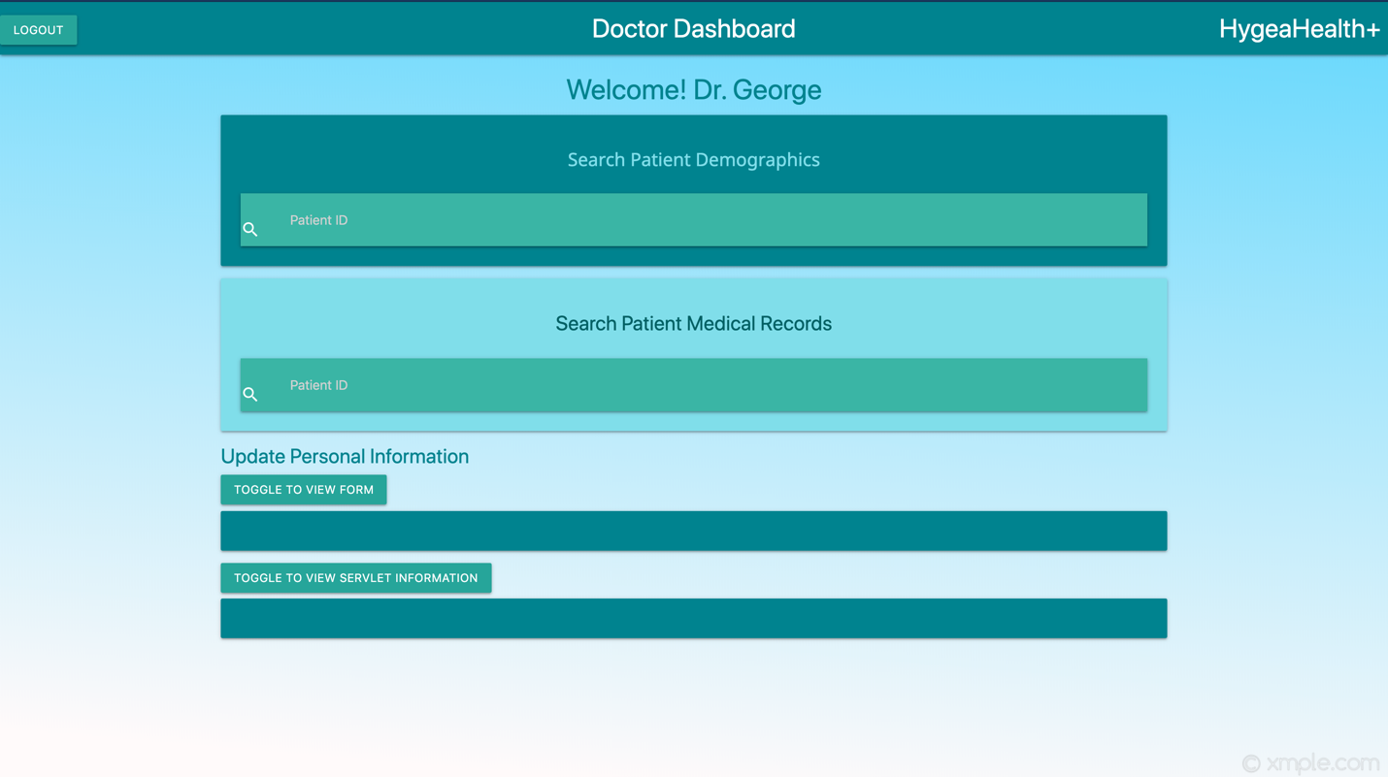

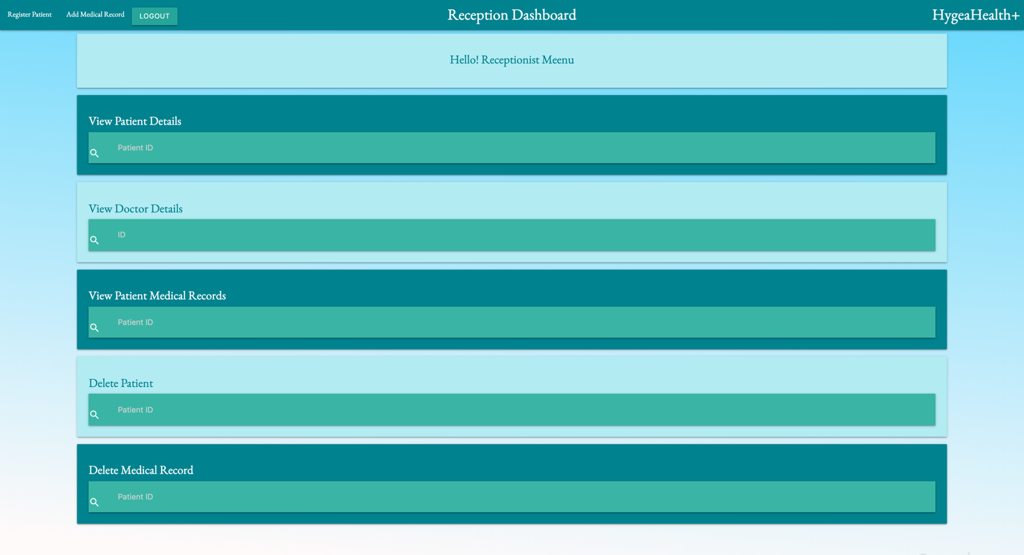

Admin Options (Search Doctor and Patient Details)

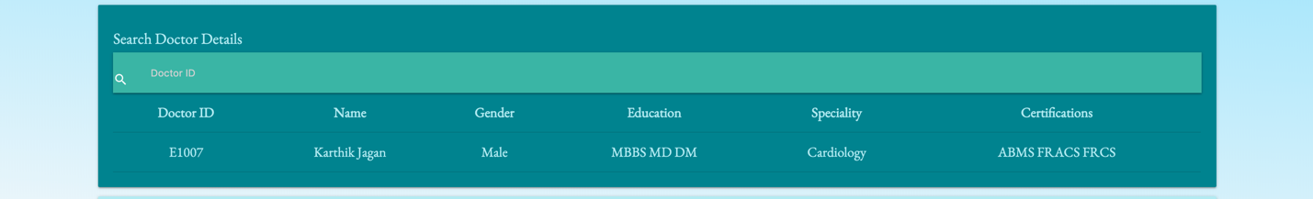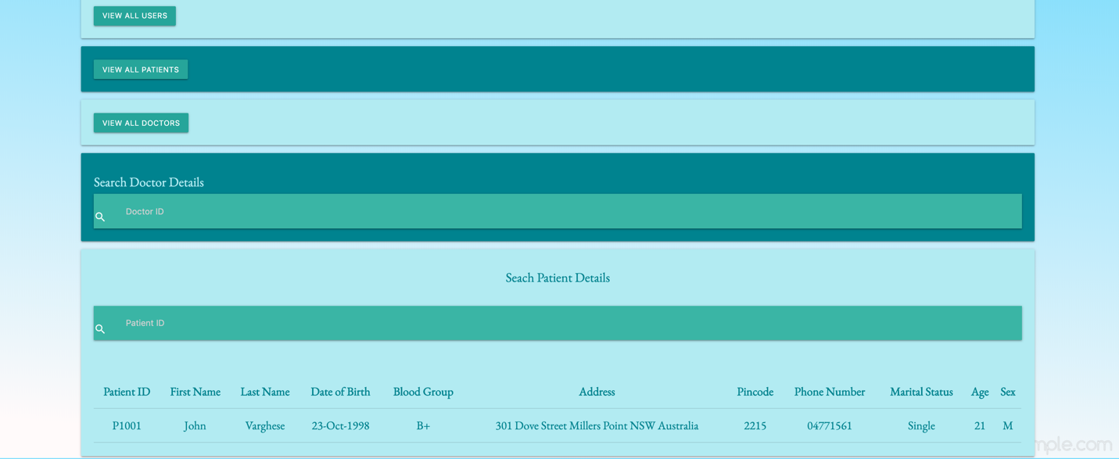

Admin Options (View All Doctors, Patients, Users)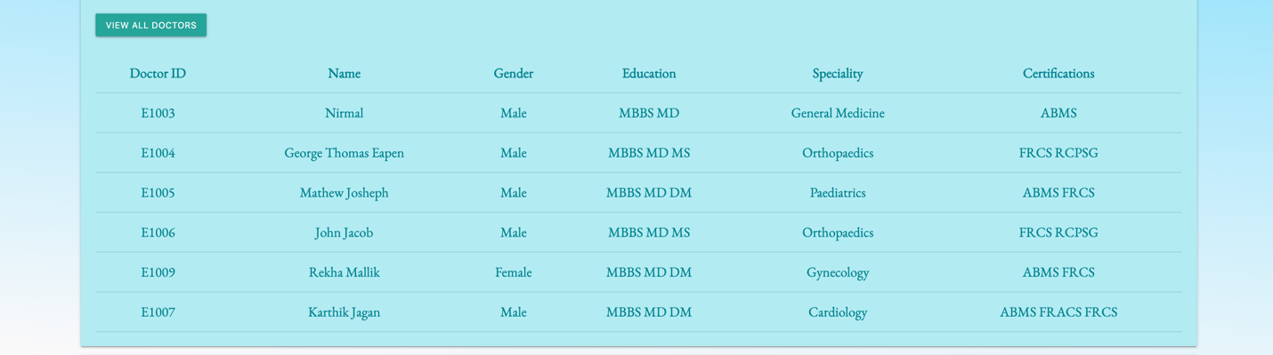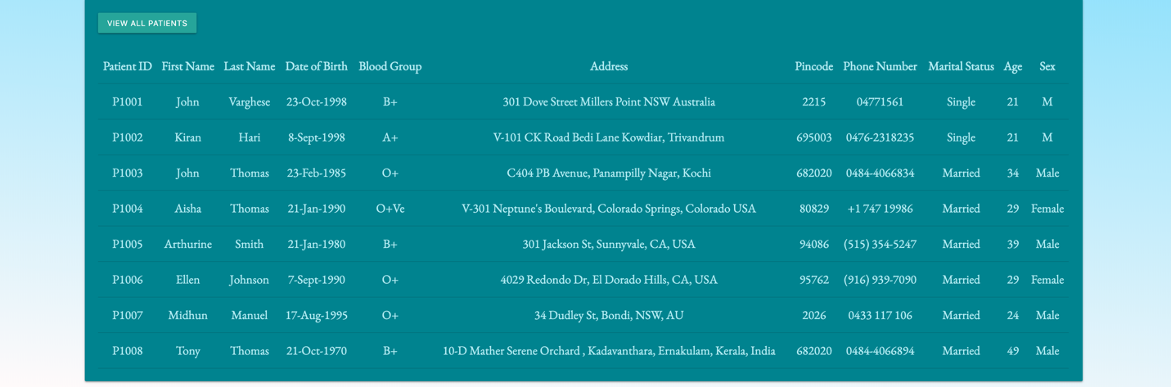

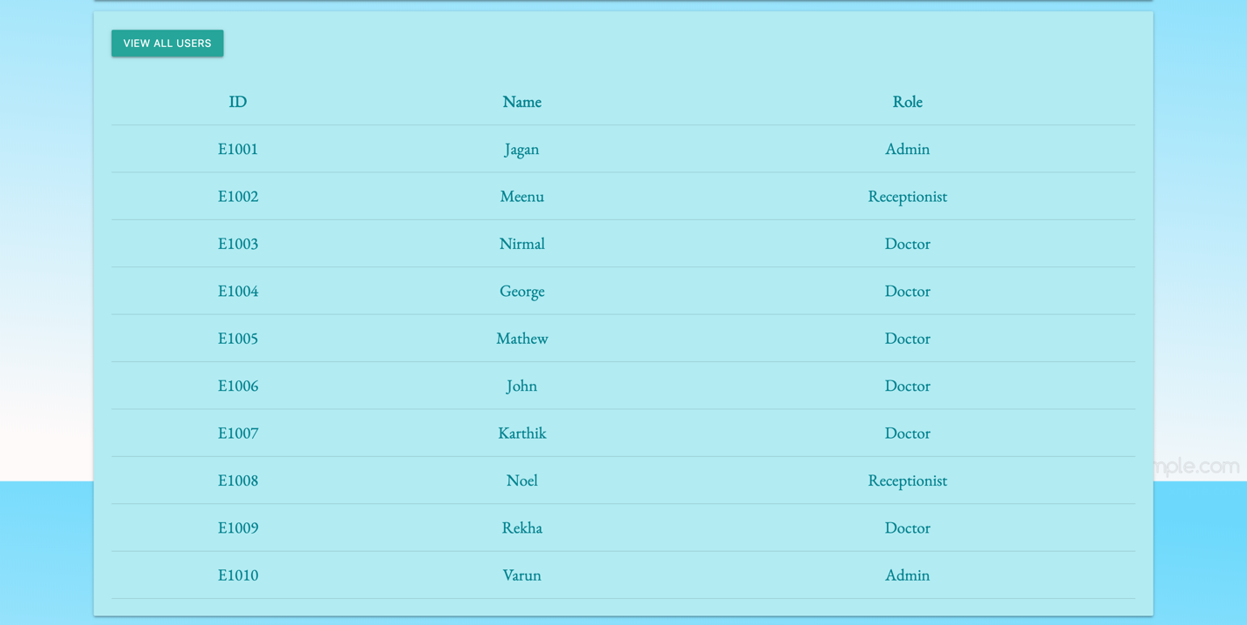

Receptionist Options

